

Moon Night Hotel Profile

Group 5

Names : Fia Valentina Setiono (2120010048)

Gendis Putri Ayu Larasati (2120010054)

Class : 2WD2

CEP CCIT

FAKULTAS TEKNIK UNIVERSITAS INDONESIA

2022

**Developed by**

1. **Fia Valentina Setiono**
2. **Gendis Putri Ayu Larasati**



**PROJECT ON**

*Moon Night Hotel Profile*

**Moon Night Hotel Profile**

Batch Code : 2WD2

Start Date : Friday, 1 July 2022  
End Date : Thursday, 7 July 2022

Name of Faculty : Riza Muhammad Nurman

Names of Developer :

1. Fia Valentina Setiono
2. Gendis Putri Ayu Larasati

Date of Submission : Thursday, 7 July 2022

**CERTIFICATE**

This is to certify that this report titled “Moon Night Hotel Profile” embodies the original work done by Fia Valentina Setiono and Gendis Putri Ayu Larasati. Project in partial fulfillment of their course requirement at NIIT.

Coordinator:

Riza Muhammad Nurman



**ACKNOWLEDGEMENT**

Authors would like to praise to Allah, Most Merciful bless and so authors can finish this project, with entitle “Moon Night Hotel Profile”. Author would like to thanks to Mr. Riza Muhammad Nurman as lecturer who has given usefull suggestion which are help authors in writing this paper.

The author realizes that this paper is still far from perfect, so the author will be very appreciative and enthusiastic, if colleagues and supervisors who have been deigned to provide suggestions and criticisms for this paper.

**SYSTEM ANALYSIS**

**System Summary**:

Moon Night Hotel Bogor is a 4-star hotel that stands majestically in the center of Bogor City. Moon Night Hotel Bogor is the second hotel under the Moon Light Hotel Group and has been open since February 18, 2018.

In this project, users can search for all information, such as hotel descriptions, hotel facilities, and the room types. this is why a good hotel reservation system is needed to make this task as easy as possible. This paper shows how the noted complicated human task can be solved by using a database Management System together with scripting and programming languages like HTML respectively as the key tools in the development of a Moon Night Hotel System.

**INTRODUCTION**

In our 3rd project, we created a simple website entitled "Moon Night Hotel". This website is the same as other hotel websites, the Moon Night Hotel website has a lot of content about hotels in it. There is a choice of Home, various types of Rooms, types of Food and Drink, Weddings (info about the building, decor references, and package prices) , Offers contains numbers or contacts that can be contacted to order, Location, and the Booking Now Form. When the booking form is filled in, at the end you will see the input amount of the order.

\

sssssssssss

**ACTIVITIES LIST**

|  |  |  |
| --- | --- | --- |
| **No** | **Date** | **The Progress** |
| 1. | July 1, 2022 | Design the website layout |
| 2. | July 2, 2022 | Disscuss website Content |
| 3. | July 4, 2022 | Start making web syntax |
| 4. | July 5, 2022 | Create web syntax |
| 5. | July 5, 2022 | Create paper |
| 6. | July 6, 2022 | Create web syntax, consul, and complete paper |
| 7. | July 7, 2022 | Create PowerPoint and record video |

**HTML PAGES**

Home

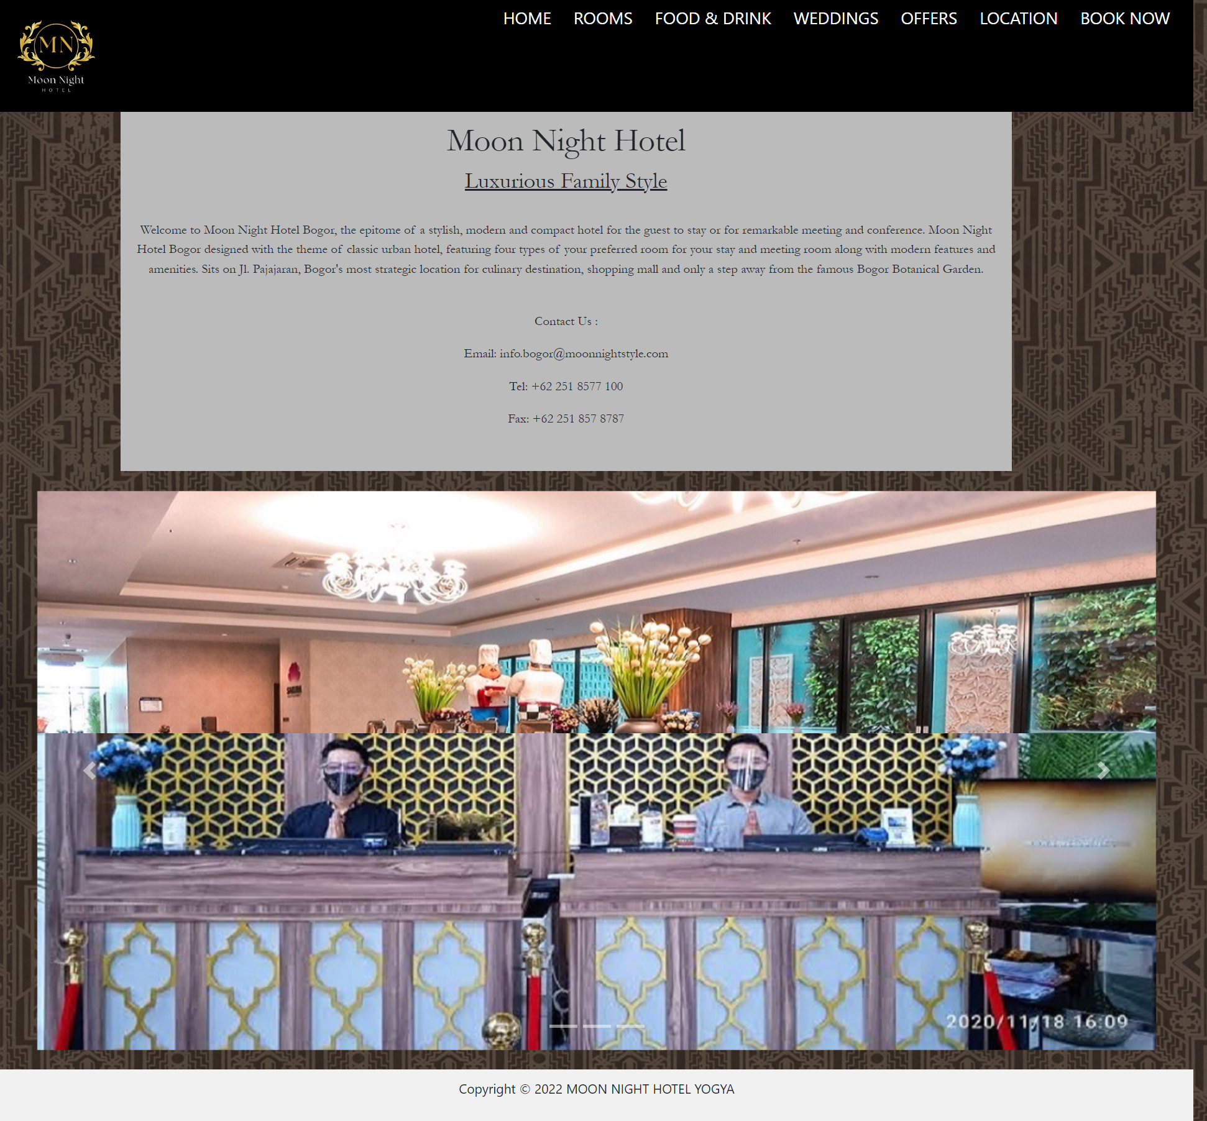

**HTML PAGES**

Rooms

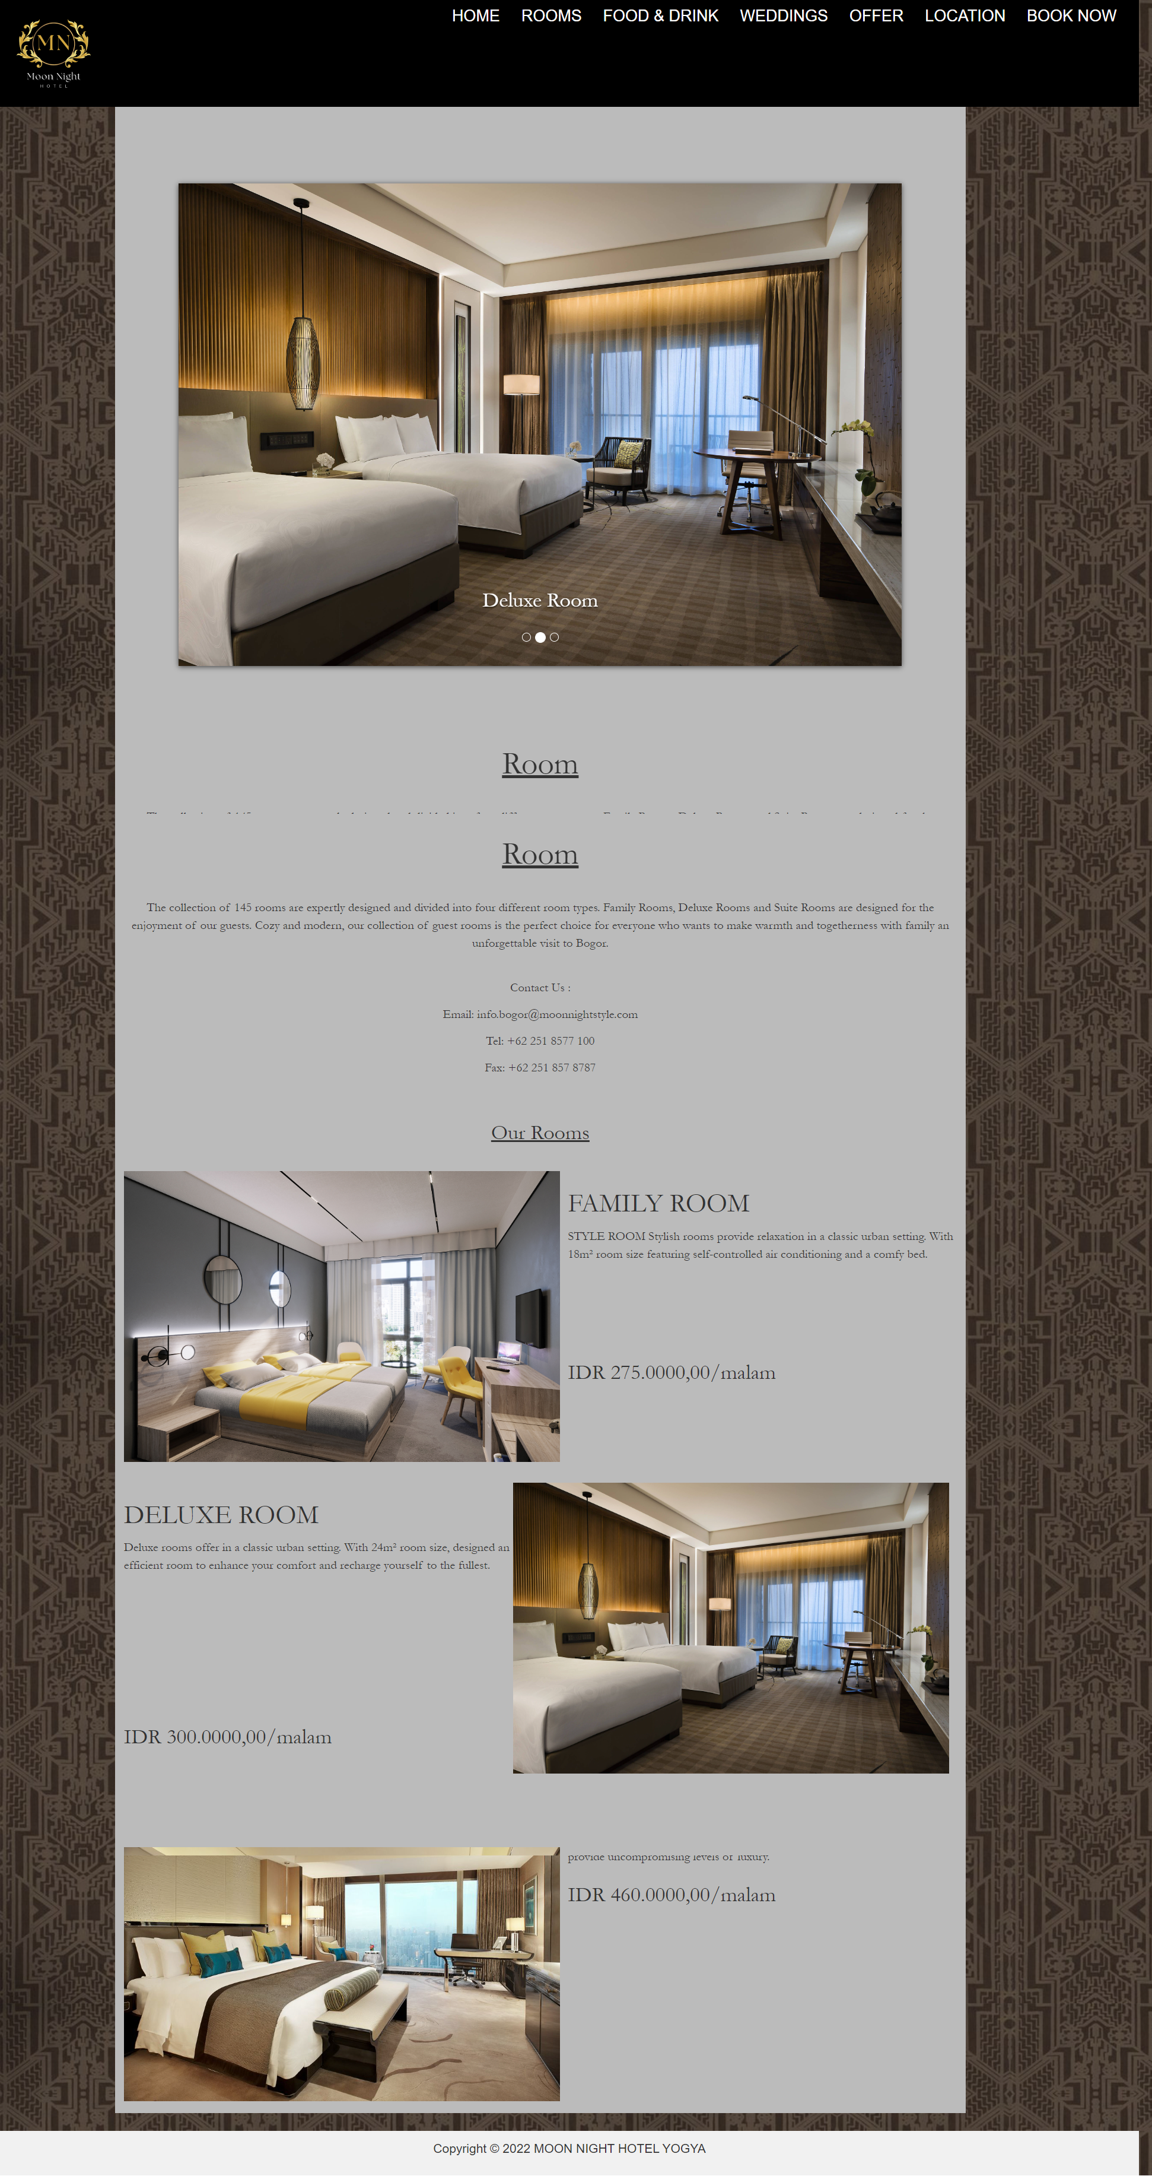

**HTML PAGES**

Food and Drink

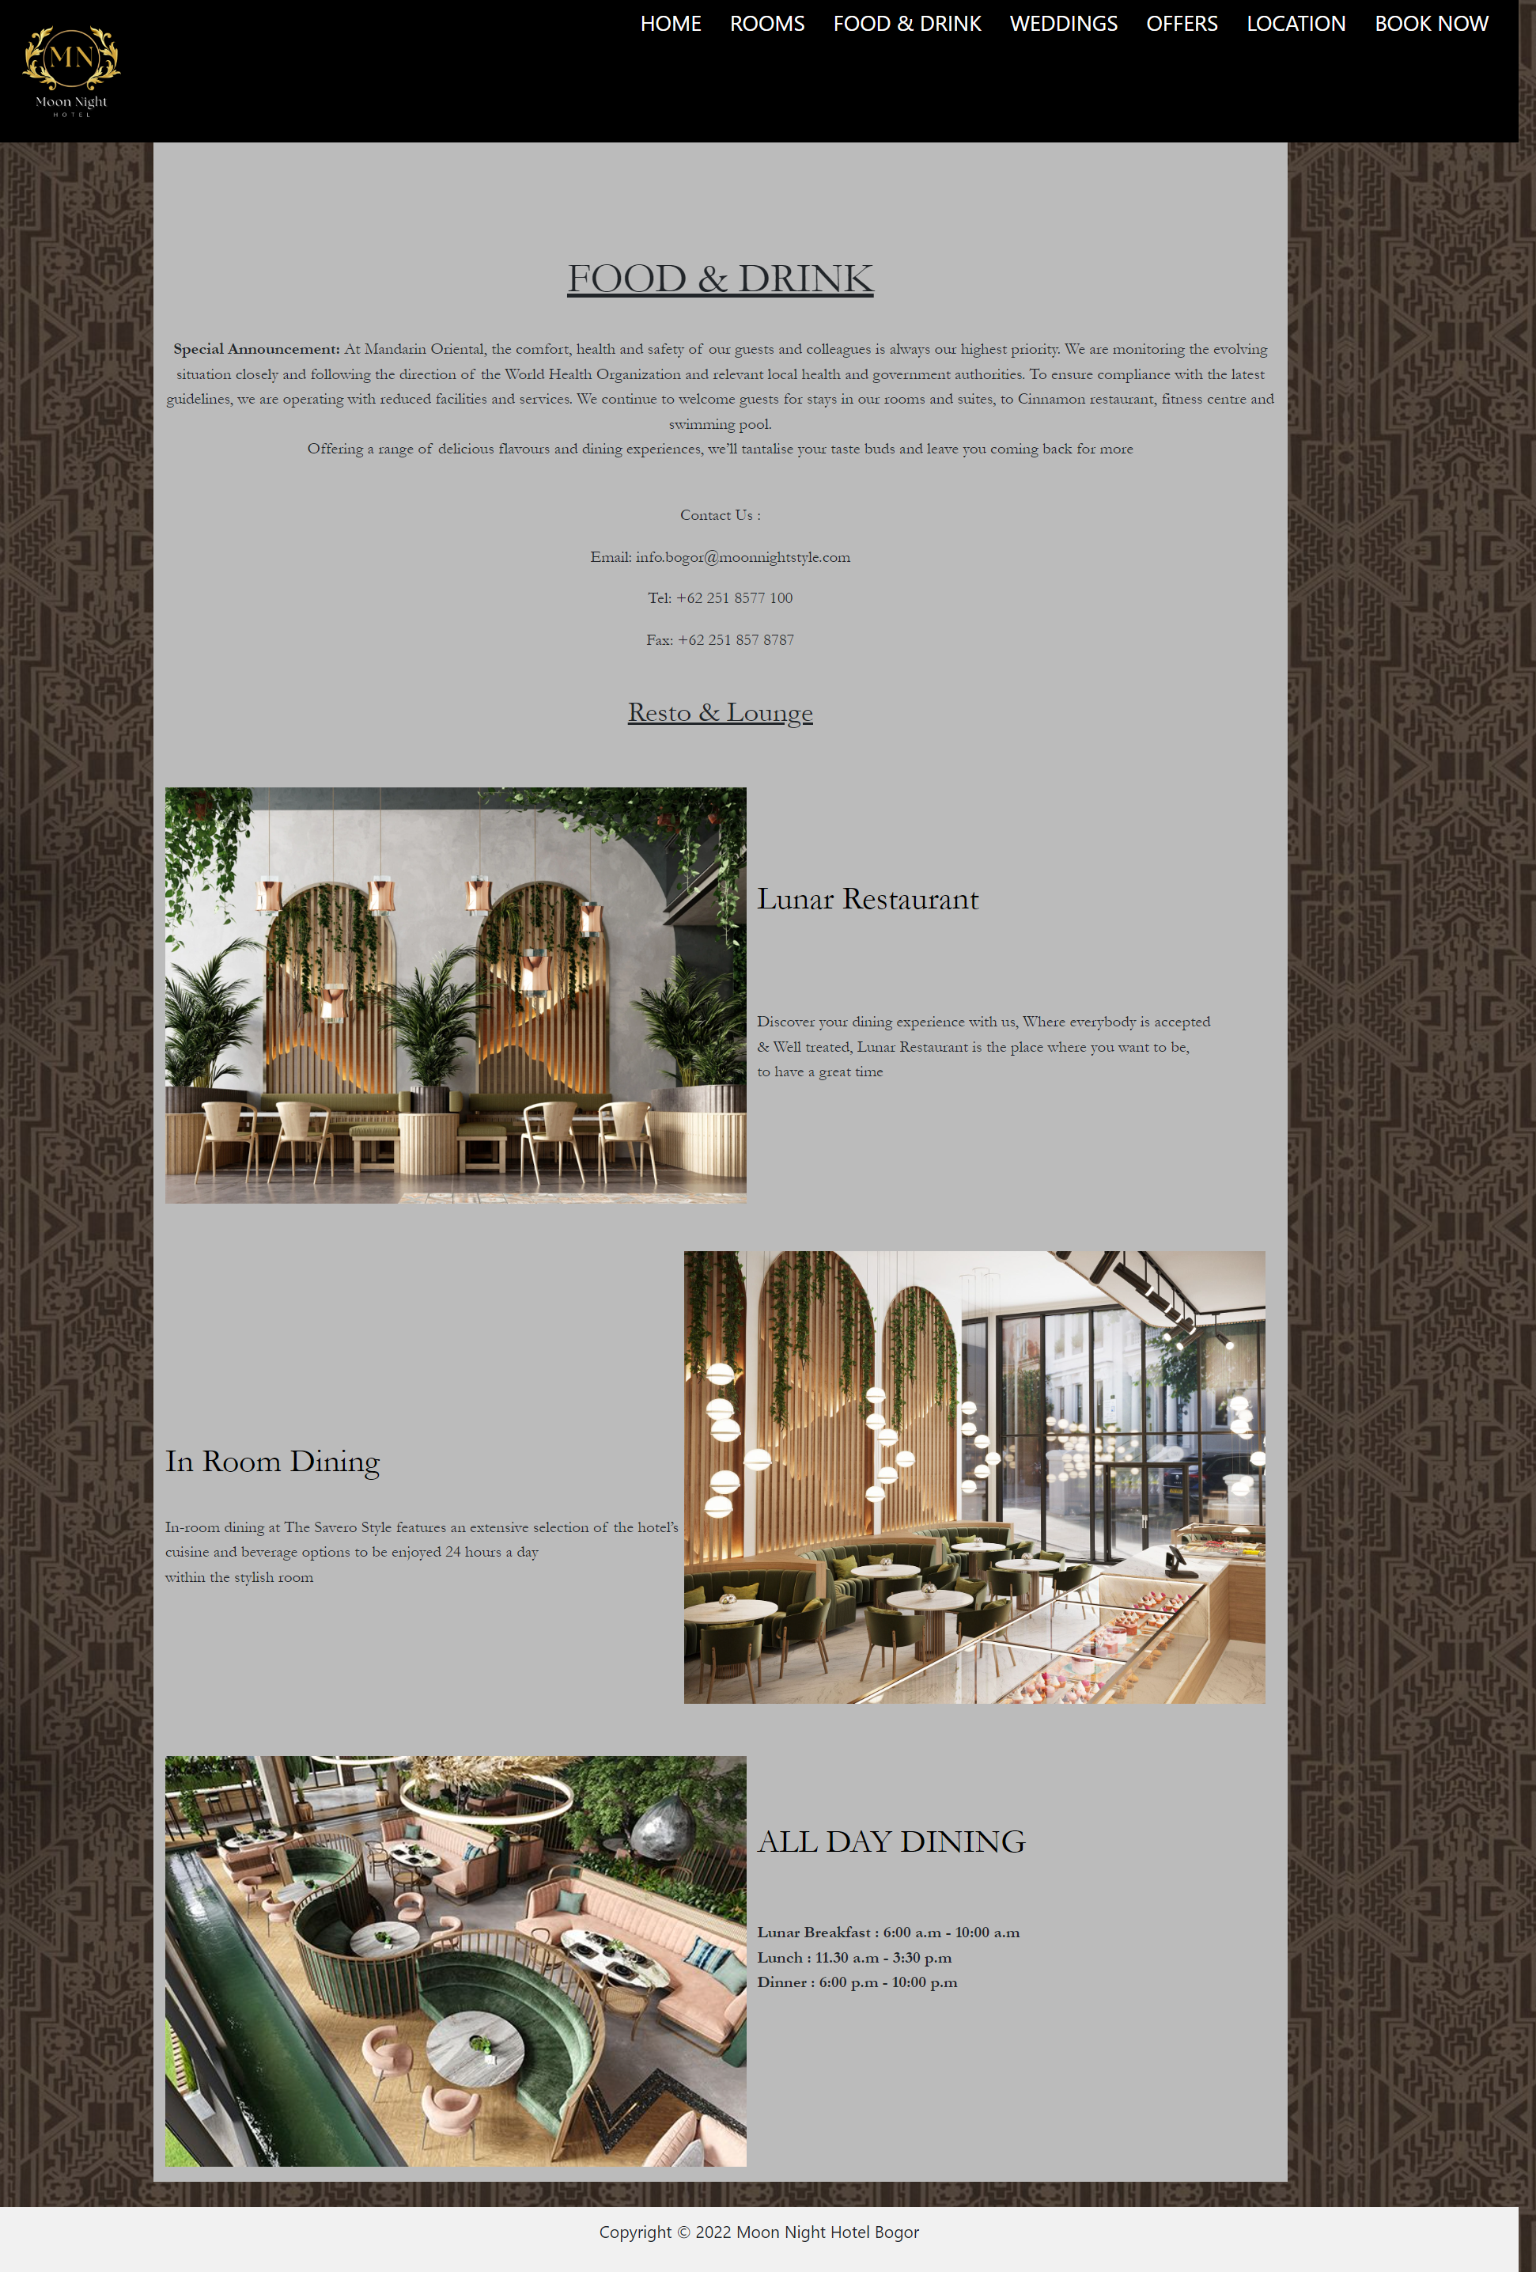

**HTML PAGES**

Wedding

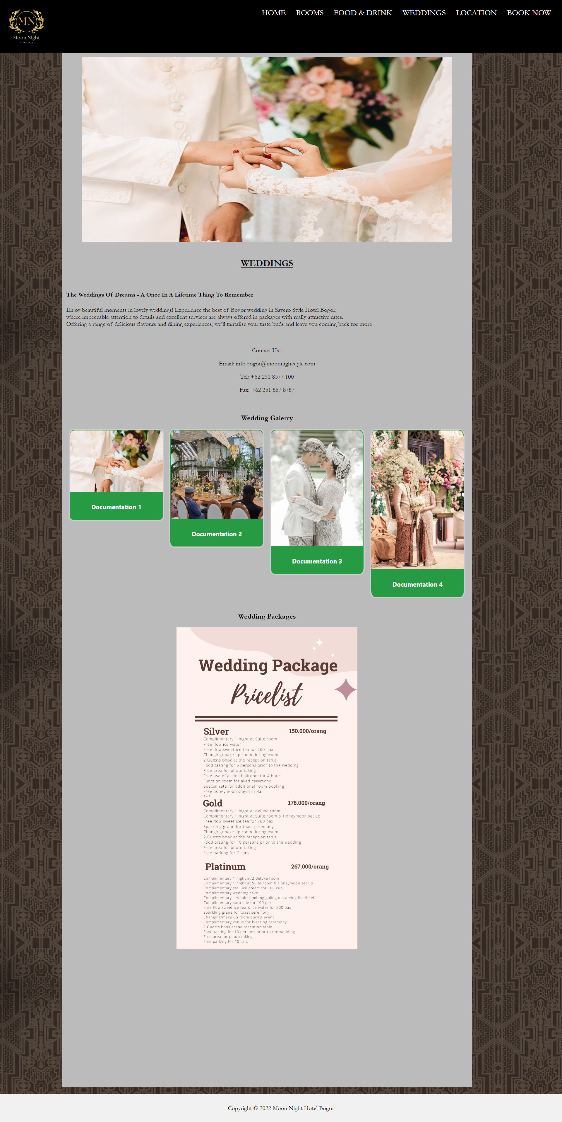

**HTML PAGES**

Location 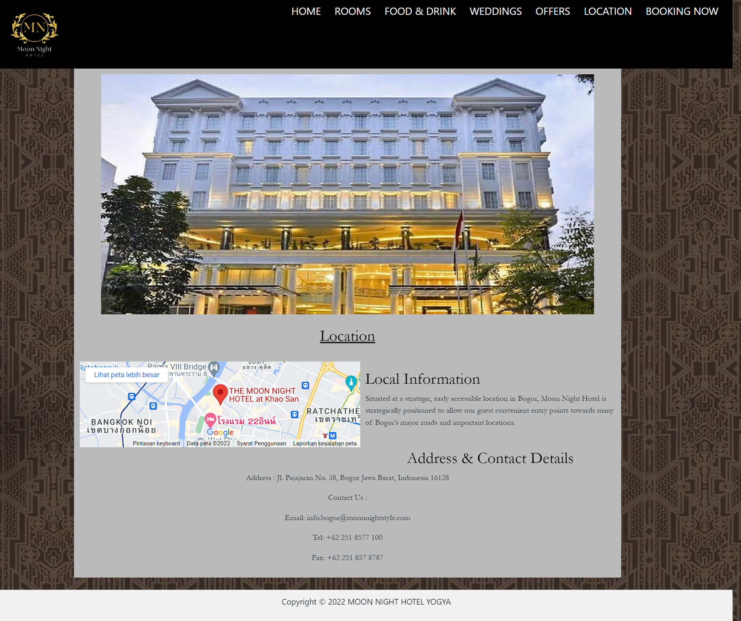

**HTML PAGES**

Offers

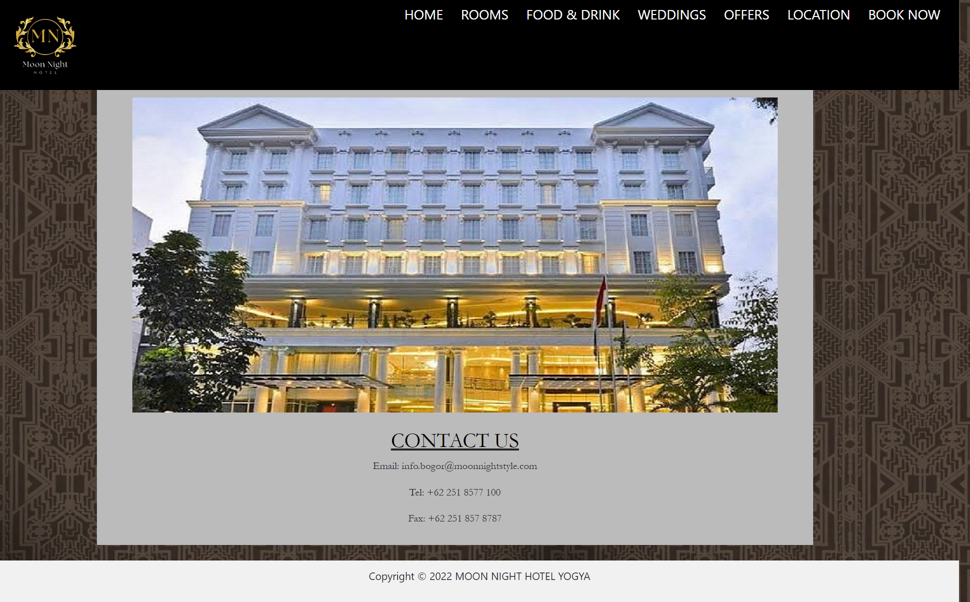

**HTML PAGES**

Hotel Booking

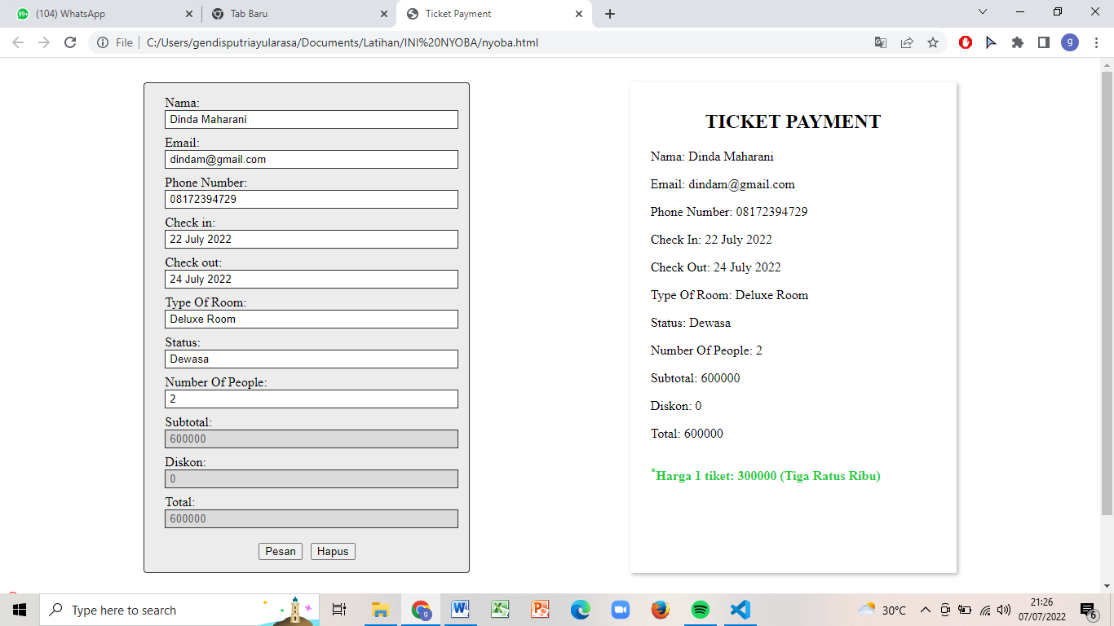

**CONFIGURATION**

**Hardware : Personal computer, intel core i5**

**Operating System : Windows 8/9/10**

**Software :**  **Visual Studio Code, Microsoft word, Microsoft Power Point**

|  |  |  |
| --- | --- | --- |
| **PROJECT FILE DETAILS** | | |
| **S.No** | **File Name** | **Remarks** |
| 1 | Project 3- Moon Night Hotel Profile.docx | Document |
| 2 | Moon Night Hotel.pptx | Power Point |
| 3 | Project 3.1 | Visual Studio Code |